# Lab 7: Displaying List Data

## Objectives

*  Format the list data as list items
*  Format the list data as cards

## Steps

### Format the list data as list items

1. **Modify** src\projects\ProjectList.js to format the project information into a HTML unordered list.

Be sure to set a key for each list item.

#### src\projects\ProjectList.js[#](https://handsonreact.com/docs/labs/js/07-DisplayingListData" \l "srcprojectsprojectlistjs" \o "Direct link to heading)

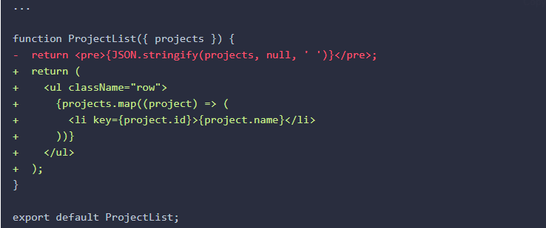

1. **Verify the project names display in the browser (they may overlap at this point).**

### Format the list data as cards

1. **Update** src\projects\ProjectList.js to format the project information into a rows of cards that show additional project information using the HTML template below.

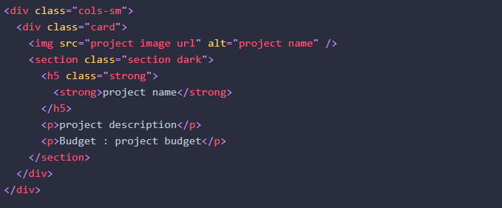

Remember that you will need to replace attribute class with className and change html attributes from src="project image url" to src={project.imageUrl}.

**TIP:** Visual Studio Code has an extension [HTML to JSX](https://marketplace.visualstudio.com/items?itemName=riazxrazor.html-to-jsx" \t "https://handsonreact.com/docs/labs/js/_blank) to do the attribute conversion.

#### src\projects\ProjectList.js

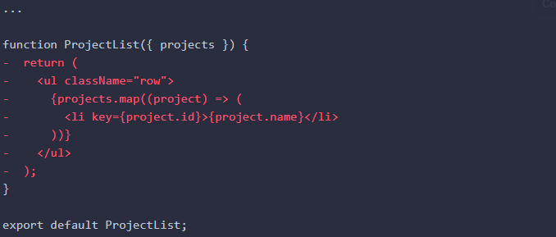

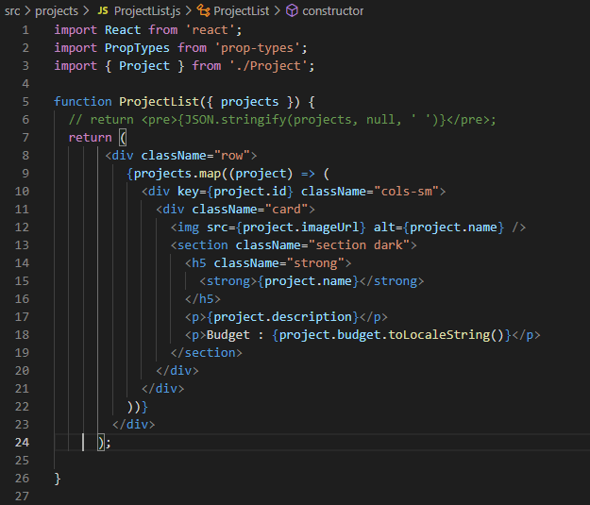

1. **Verify** the **project** **data** **displays** correctly in the browser.

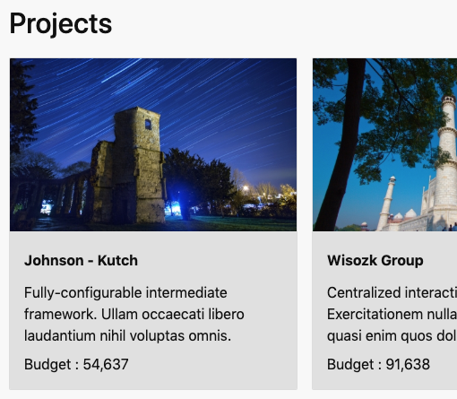

Note you can use toLocaleString to format the project budget number in JavaScript.

<p>Budget : {project.budget.toLocaleString()}</p>

If you need to format something in React, ask yourself or google.com: How would I do this in JavaScript?

### ✔ You have completed Lab 7